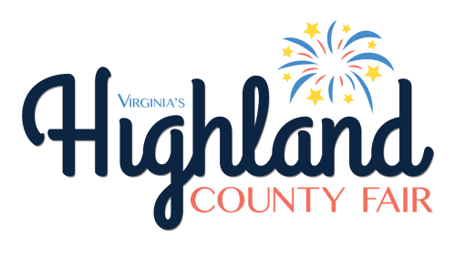
PARADE ENTRY #.........

PARADE CLASS
(Check entry)

____4x4 Vehicle (not antique)
____Antique: Tractor (25 yrs & older)
____Antique Vehicle: 1949 & older
____Antique Vehicle: 1950-1969
____Antique Vehicle: 1970-1989
____Antique Vehicle: 1990-2001
____ATV/SxS/Golf Car
____Business Promotion
____College Promotion
____Cycle & Cyclist
____Decorated Float ____Equine & Rider
____Fair Theme Float
____Fire Truck/Unit
____Marching Band
____Miscellaneous
____Muscle Car (any year)
____Pageant Winner (non-float)
____Pets on Parade
____Rescue Squad/Unit
____Walking Group/Performers

PARADE REGISTRATION

Entry Description __________________________________
_________________________________

Responsible Party/Contact Name______________________

Address _________________________________________
or Email _________________________________________

Phone # _______________________

The Responsible Party agrees to hold the Highland County Fair Association, Inc. harmless and to indemnify the Highland County Fair Association, Inc. from any and all damages, costs, and expenses arising out of or related to the actions or omissions of the Responsible Party, the Entity, and the officers, employees, invitees, guests, and agents of either.
EQUINE ENTRIES
If involved in equine activities pursuant to Section 3.1-796.132 of the Code of Virginia the undersigned(s) execute(s) this waiver of the undersigned(s) rights to sue and agree(s) to assume all risks inherent in equine activities and have notice of all the risks inherent in equine activities including (i) the propensity of equine to behave in dangerous ways which may result in injury to the participant; (ii) the inability to predict an animal's reaction to sound, movements, objects, persons, or other animals; and (iii) hazards of surface or subsurface conditions.

All equine entries must present proof of a negative Coggins test within the last twelve months upon registering.

The Coggins number must be listed for each horse.
Name of Horse______________________
Coggins #__________________________
Date of test_________________

Verified at registration by (initial) _____

I verify that the following requirements have been checked, and that the above-listed entry is compliant with all: (This listing is not meant to be all-inclusive, but provided to give some guidance.)
- Vehicle has been checked for any safety concerns and is in proper working order. Any vehicle unable to complete the parade route will be towed at owner's expense.
- Vehicle is insured with a liability insurance policy.
- Hitches are secured.
- All items/decorations are safely secured on float/vehicle/wagon
- People on floats or moving units are safely positioned on unit in order to prevent falls or other injury.
- At least 30-foot intervals between entries should be maintained throughout parade.
- Be mindful and cautious of pedestrians along route.

Failure to sign this form and present proof of negative Coggins test (for equine entries) could result in dismissal from parade. The Highland County Fair Association, Inc. reserves the right to limit the participation of any entry for any reason. All entries are required to smile, wave to crowd, and have a genuine good time!

_________________________________
Signature of Responsible Party

_______________________________
Date

